Project Design Phase-II
Data Flow Diagram & User Stories

Date | 5 July 2026
Team ID
Project Name | OptiCrop: Smart Agricultural Production Optimization Engine
Maximum Marks | 4 Marks

Data Flow Diagrams:
A Data Flow Diagram (DFD) is a traditional visual representation of the information flows within a system. A neat and clear DFD can depict the right amount of the system requirement graphically. It shows how data enters and leaves the system, what changes the information, and where data is stored.

Example: (Simplified)
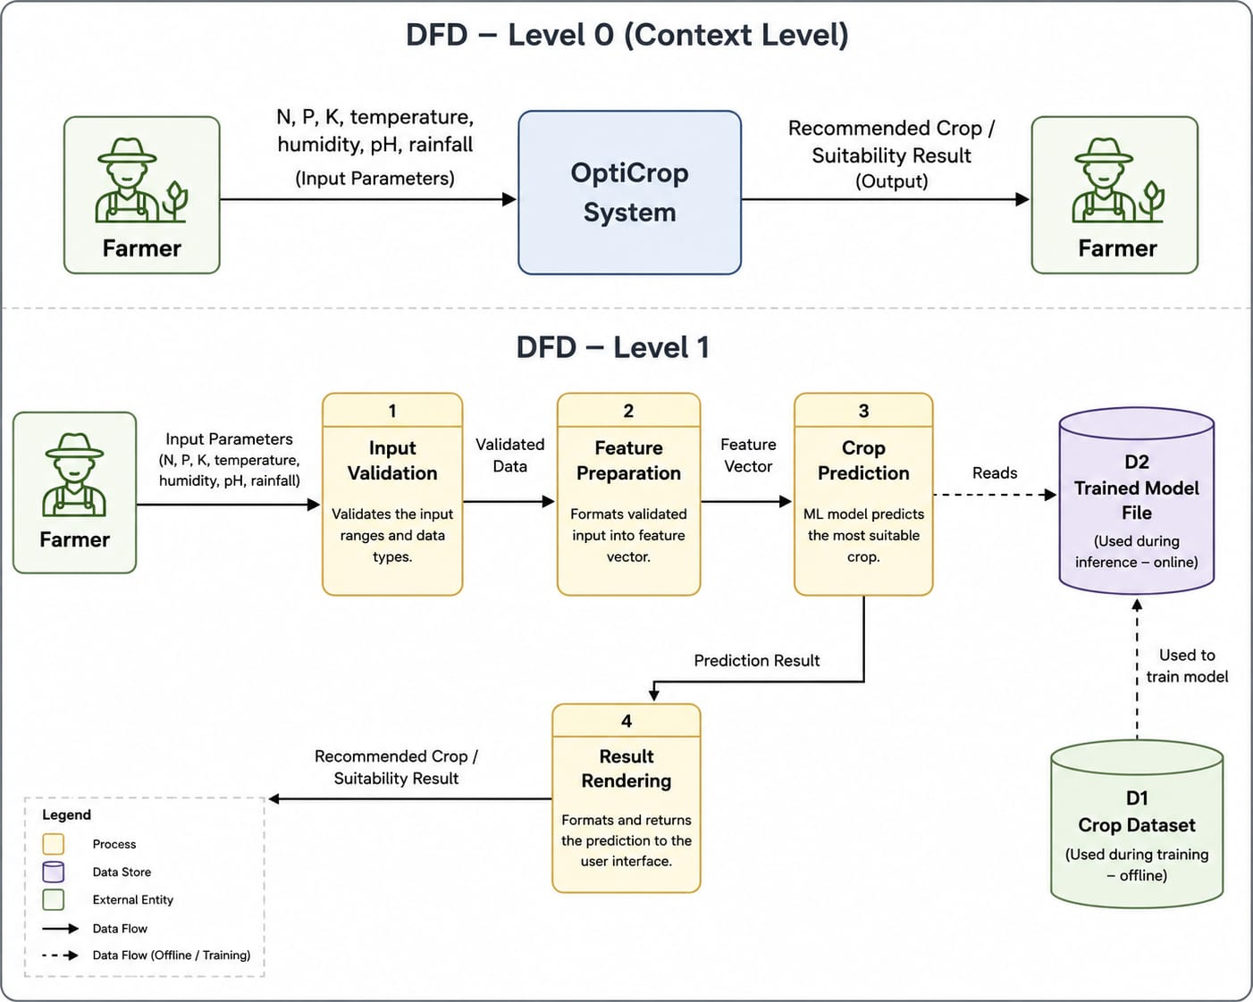


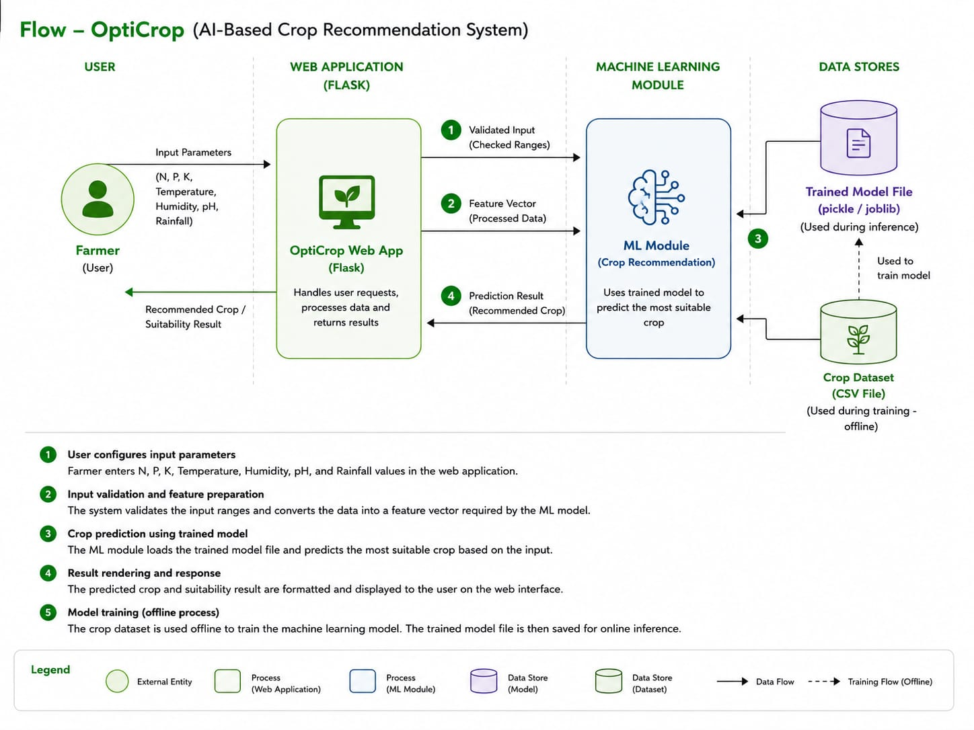

User Stories
Use the below template to list all the user stories for the product.
User Type | Functional Requirement (Epic) | User Story Number | User Story / Task | Acceptance criteria | Priority | Release
Farmer (Web User) | Registration | USN-1 | As a farmer, I can register for the application using my email and password. | I can successfully create an account and access the dashboard. | High | Sprint-1
Farmer (Web User) | Login | USN-2 | As a farmer, I can log in using my registered email and password. | I can securely log in and access my dashboard. | High | Sprint-1
Farmer (Web User) | Dashboard | USN-3 | As a farmer, I can view the OptiCrop dashboard after logging in. | The dashboard loads successfully with all available options. | High | Sprint-1
Farmer (Web User) | Crop Recommendation | USN-4 | As a farmer, I can enter soil nutrients (N, P, K), pH, temperature, humidity, and rainfall to receive the best crop recommendation. | The system displays the recommended crop accurately. | High | Sprint-1
Farmer (Web User) | Crop Suitabilty Check | USN-5 | As a farmer, I can check whether my preferred crop is suitable for my soil and environmental conditions. | The system displays whether the crop is suitable or not with recommendations. | High | Sprint-1
Farmer (Web User) | Prediction History | USN-6 | As a farmer, I can view my previous crop recommendations. | Previous recommendations are displayed correctly. | Medium | Sprint-2
Farmer (Web User) | User Profile | USN-7 | As a farmer, I can update my profile information. | Profile details are updated successfully. | Medium | Sprint-2
Researcher/Admin | Analytics Dashboard | USN-8 | As an administrator, I can view aggregated crop recommendation statistics and trends. | Charts and analytics are displayed correctly. | Medium | Sprint-2
Administrator | Dataset Management | USN-9 | As an administrator, I can manage the agricultural dataset used for predictions. | Dataset can be uploaded or updated successfully. | Medium | Sprint-2
Administrator | Model Management | USN-10 | As an administrator, I can upload or replace the trained machine learning model. | New model loads successfully and generates predictions. | Low | Sprint-3
Farmer (Web User) | Weather Integration (Future Scope) | USN-11 | As a farmer, I want weather details to be fetched automatically so that I don't have to enter them manually. | Weather parameters are automatically populated. | Low | sprint-3
Farmer (Web User) | Multi-language Support (Future Scope) | USN-12 | As a farmer, I want the application in my local language for better usability. | The interface is displayed in the selected language. | Low | sprint-3

